Kim’s Christmas/Birthday List

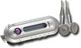
Watches: From Fossil.com
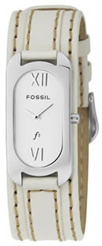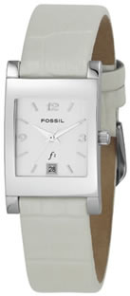
Any kind of MP3 Player

Any kind of comfy house slippers
Top of Form
Any kind of MP3 Player

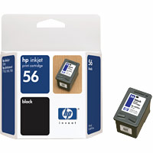
Jason Mraz – Live CD
Available to order at http://stores.musictoday.com/store/product.asp?dept%5Fid=1322&pf%5Fid=JZCD02&band%5Fid=485&sfid=2
Hewlett Packard 56 Black Ink Cartridge, C6656AN & Computer Print Paper

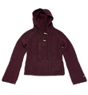


Sweaters
Aeropostale Cable Knit Sweater w/Toggle Closure
TEMPTING TREASURES COFFRET from Victoria Secret…$45

Aeropostale
Long Sleeve Crew
$19.50
NOW $7.99

Tony –

